Table of Contents
Abstract ii
Disclaimer iii
Acknowledgement iv
List of Tables vii
List of Figures viii
Notation ix
Chapter One: EML 4551C 1
1.1 Project Scope 1
1.2 Customer Needs 1
1.3 Functional Decomposition 1
1.4 Target Summary 1
1.5 Concept Generation 1
Concept 1. 1
Concept 2. 1
Concept 3. 1
Concept 4. 1
Concept n+1. 1
1.6 Concept Selection 2
1.8 Spring Project Plan 2
Chapter Two: EML 4552C 3
2.1 Spring Plan 3
Project Plan. 3
Build Plan. 3
Appendices 4
Appendix A: Code of Conduct 6
Appendix B: Functional Decomposition 7
Appendix C: Target Catalog 8
Appendix A: APA Headings (delete) 8
Heading 1 is Centered, Boldface, Uppercase and Lowercase Heading 8
Heading 2 is Flush Left, Boldface, Uppercase and Lowercase Heading 8
Heading 3 is indented, boldface lowercase paragraph heading ending with a period. 8
Appendix B Figures and Tables (delete) 9
Flush Left, Boldface, Uppercase and Lowercase 10
References 11

Chapter One: EML 4551C

1.1 Project Scope
Team 507 will be working with Cummins to develop a battery pack cooling concept for hybrid vehicles. Our goals, markets, assumptions, and stakeholders are all outlined below.
1.1.1 Project Description
One of the limiting factors for hybrid vehicles is the amount of heat that the battery releases during long use and rapid acceleration. This can cause the battery pack to overheat causing the battery to catch on fire. These fires can be extremely dangerous and are very hard to put out. Team 507 has been tasked with developing a concept that can efficiently cool a hybrid vehicle battery pack. The cooling method should cool the battery at least 5% more effectively than the market benchmark without any substantial change in production costs. The design will be based on the Nissan Leaf battery pack but should be applicable to other hybrid vehicles battery packs as well.
1.1.2 Key Goals
Our goals for this project are based on improving preexisting battery pack performance benchmarks. We are not aiming to reinvent the battery pack from the ground up. We simply want to explore methods we can use to modify the battery modules and heat sinks in order to pull more heat from the batteries. Our first goal is to pull heat from a hybrid vehicle battery pack at a rate that is at least 5% greater than existing cooling methods. The second goal is to avoid substantial increases in production and ownership costs. The third goal of our project is our design must withstand thermal cycling, shock and vibration, and be chemically inert. Our fourth goal is to keep the battery pack temperature within efficient operating range. Our final goal is to follow all state and federal regulations for safe battery operation and testing.
1.1.3 Markets
Our primary markets include car companies that develop hybrid vehicles and battery manufacturers. Our main goal is to find a method to cool a battery that will go into a hybrid vehicle, so hybrid manufacturers will directly benefit from our method. Battery manufacturers can also use our method to make their batteries more efficient. Our secondary markets include car companies that develop fully electric vehicles as well as environmental organizations. While our method is for hybrid vehicles, fully electric vehicle manufacturers can draw inspiration from our method and use it to cool electric vehicles. Environmental organizations are included because better efficiency in batteries will lessen the need for fossil fuels, leading to a decreased carbon footprint.
1.1.4 Assumptions
The assumptions that we made to refine the scope of our project are as follows. It is assumed that the battery that we will be using to base our design on is a 10-kWh lithium-ion battery pack. It is also assumed that the battery cannot be opened past the module level. Opening a lithium-ion battery past the module level becomes very dangerous as there are chemicals and fire hazards. The third assumption that we made is that the battery will be subjected to a variety of operating conditions during its use.
1.1.5 Stakeholders
The stakeholders that Team 507 has are Cummins, Dr. McConomy, Dr. Juan Ordonez, Dr. Michael Hays, and the FAMU-FSU College of Engineering.
Cummins is the sponsor for our project and will provide funding and advising for our project. Cummins is looking to implement our design into the development of new hybrid vehicles if we meet the goals that we have set for our project. Dr. Michael Hays is our Cummins advisor and will be overseeing our project.
Another stakeholder for our project is Dr. McConomy. Dr. McConomy is our senior design professor and oversees our project and provides advice and feedback throughout the design of our project.
Dr. Juan Ordonez is the faculty advisor for our project. Dr. Ordonez specializes in heat transfer, advanced power systems, fuel cells, and heat exchanger design cooling of electronics. Dr. Ordonez will provide advice throughout the project to ensure that our design can meet our goals.
Our last stakeholder is the FAMU-FSU College of Engineering. We represent the FAMU-FSU College of Engineering through our project and the success of our project shows the education, preparation, and engineering knowledge that the college instils in its students.

Appendices

Appendix A: Code of Conduct
Mission Statement:
Our goal is to use our collective engineering knowledge to provide the best possible solution to the problem given to us by our sponsor. We will work in a professional manner and at the highest level possible in order to accomplish this goal.
Outside Obligations:
• Anthony - TA recitation Fridays 11am-1pm. Office hours 2pm-3pm Tuesday & Thursday.
• Jacob - Work Monday-Thursday 10am-2pm & Friday 10am-10pm.
• Clayton Carlson - Monday 10:30am-5pm, Wednesday 8am-2pm, Friday 8pm-5pm.
Team Roles (Subject to change):
• Jacob Owens - Design Engineer (Proficient in CAD software and prototyping)
• Clayton Carlson - Thermal Fluids Design (Has a great general knowledge of thermal fluids behavior and design)
• Chris Carley - Controls Engineer (Focus on mechatronics and mechanics)
• Corey Kelley - Systems Engineer (Focus on the long-term behaviors of the system)
• Anthony Vicary - Materials engineer (Focus on materials selection and wear and behavior of the system in different environments)
Other tasks not included in the roles listed above will be assigned to group members by entire team based on current project workload, member expertise with specified task, and task priority as it relates to project status. The team will work together to distribute other tasks in a fair and appropriate manner. Team will have no specified leader. All group members hold equal weight on all decisions and issues throughout the project.
Communication:
Communication between team members will mainly be done through the group message in Groupme. Any formal communication with the sponsor will be done through school emails or the decided upon video meeting platform. Team members are required to respond to all messages or emails directed at them within 24 hours. All group assignments must be reviewed by all team members before a submission can be posted. Scheduling will be done using When2meet. Team members will enter times when they are unavailable to meet, and a group will use the calendar to find a time that works for all members.
Attendance:
All group members must attend meetings with the sponsor. If someone has a valid reason for having to miss a sponsor meeting, it must be communicated with the group before the meeting is held. If the team decides to meet to work on the project during a time that a group member has an outside obligation listed in this form, the group member should not be expected to attend. Group members will attend all in-class lectures unless they have a valid reason for missing a lecture. If a group member misses a meeting or scheduled work time without notifying the other members, the group will determine the work that was missed by that member and will be required to finish that work on their own time. If a group member misses three scheduled meetings or work times without notification, the group will have a meeting to discuss how to move forward.

How to Notify Group:
If unable to attend a meeting or work session, a group member should notify the group either by email or the group chat at least 24 hours before the scheduled meeting or work session. Professional Meetings: Meetings with the sponsor will be held in a professional manner. All group members are expected to be ready to meet at least 5 minutes early. Meeting minutes will be kept, and notes taken by all group members. These notes and minutes will be condensed and organized for future meetings and work. A single group member will be chosen to briefly update the sponsor on the work that has been done since the previous meeting and the current state of the project at the beginning of each meeting.
Dress Code:
• Meetings/Video meetings - Business casual (Button-up dress shirt or nice collared shirt, no hats or jewelry).
• Project presentations - White button up and tie. Khakis or dress slacks.
• Senior design day - Suit and tie
How do We Attempt to Solve Problems Before Contacting Dr. McConomy?:
All group members discuss the problem either in person or in the group message and attempt to reach an agreement. If a solution cannot be reached a vote can be requested by any group member on any issue and the majority vote will decide the outcome.
At What Point Do We Contact Dr. McConomy?:
If an agreement cannot be reached through discussion or a vote, we will reach out to a T.A.. If an agreement cannot be reached with the T.A.’s help then we will reach out to Dr. McConomy.

What Do We Ask of Dr. McConomy When Going to Him to Resolve an Issue?:
We ask that he provides his recommendation on how we should move forward so that we can discuss and resolve the situation as a group.
How Do We Amend This Code of Conduct?:
To amend the code of conduct a vote must be held and 4 out of 5 members must agree on an amendment. An amendment to the Code of Conduct may be brought forth at any point during the project. Statement of Understanding By signing below, you acknowledge that you have read the code of conduct and agree to follow it throughout the course of this group senior design project.
Statement of Understanding:
By signing below, you acknowledge that you have read the code of conduct and agree to follow it throughout the course of this group senior design project.
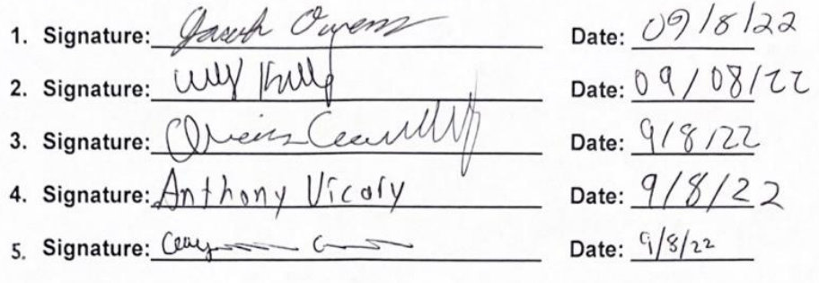

Appendix B: Functional Decomposition

Appendix C: Target Catalog

Appendix A: APA Headings (delete)

Heading 1 is Centered, Boldface, Uppercase and Lowercase Heading

Heading 2 is Flush Left, Boldface, Uppercase and Lowercase Heading

Heading 3 is indented, boldface lowercase paragraph heading ending with a period.

Heading 4 is indented, boldface, italicized, lowercase paragraph heading ending with a period.

Heading 5 is indented, italicized, lowercase paragraph heading ending with a period.

See publication manual of the American Psychological Association page 62

Appendix B Figures and Tables (delete)
The text above the cation always introduces the reference material such as a figure or table. You should never show reference material then present the discussion. You can split the discussion around the reference material, but you should always introduce the reference material in your text first then show the information. If you look at the Figure 1 below the caption has a period after the figure number and is left justified whereas the figure itself is centered.

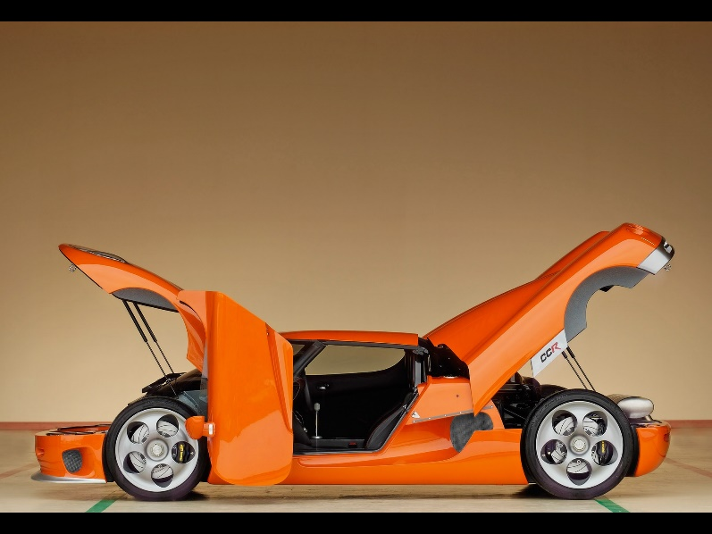
Figure 1. Flush left, normal font settings, sentence case, and ends with a period.
In addition, table captions are placed above the table and have a return after the table number. The second line of the caption provided the description. Note, there is a difference between a return and enter. A return is accomplished with the shortcut key shift + enter. Last, unlike the caption for a figure, a table caption does not end with a period, nor is there a period after the table number.

Table 1
The Word Table and the Table Number are Normal Font and Flush Left. The Caption is Flush Left, Italicized, Uppercase and Lowercase
Level of heading | Format
1 | Centered, Boldface, Uppercase and Lowercase Heading
2 | Flush Left, Boldface, Uppercase and Lowercase
3 | Indented, boldface lowercase paragraph heading ending with a period
4 | Indented, boldface, italicized, lowercase paragraph heading ending with a period.
5 | Indented, italicized, lowercase paragraph heading ending with a period.

References
There are no sources in the current document.

